

A Project Report

On

Grab It

By

**Aakansha Shrivas**

B.Sc. IT

# Batch: - 2020 – 4970

# Centre: Mumbai, Thane

Under the Guidance of

**Jayant V.**

Technical Trainer

# **EduBridge**

(School of coding)

**Introduction:**

Our project explains about the Online Food Management System. This project mainly explains the various actions related to Registration of a user and login credentials.

Our Project Includes:

* Registration
* Login/Logout

I have developed this Application in Java, JSP, Servlets and MySQL. It’s a web-based projects so I have used HTML, CSS also.

The main feature of the project is to manage the records of customers.

**Software Requirements:**

**Front end:** Java/J2EE technologies (Servlet, JSP), HTML, CSS, JDBC.

**Back end:** MySQL.

**Middleware/Server:** Apache Tomcat v8.0.

**IDE:** Eclipse IDE for Java EE Developers

**Browser:** Best result on Google Chrome

**Operating System:** Window XP (Minimum).

**ERD (Entity Relationship Diagram):**

**Data Dictionary:**

Customer

**Table name: regi**

create database edubridgee;

use edubridgee;

create table userss(userid varchar(20) not null,

password varchar(20)not null,

fname varchar(20)not null,

lname varchar(20)not null,

email varchar(20)not null,

primary key (userid)

);

select * from userss;

**Screenshots:**

**Home Page:**



**Index Page:**

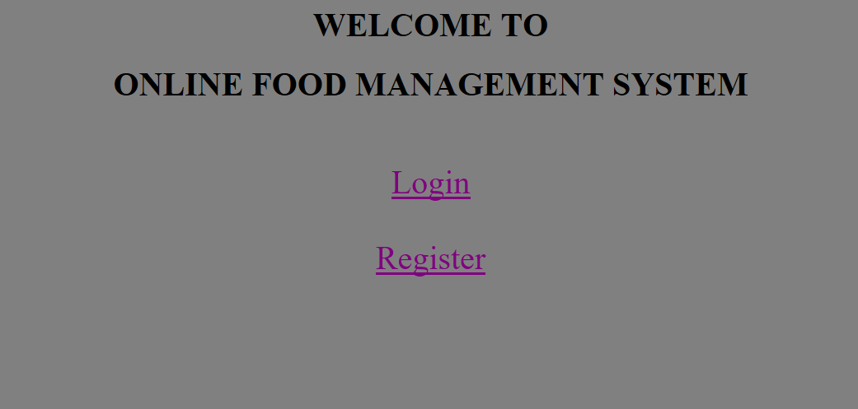

**Registration page:**

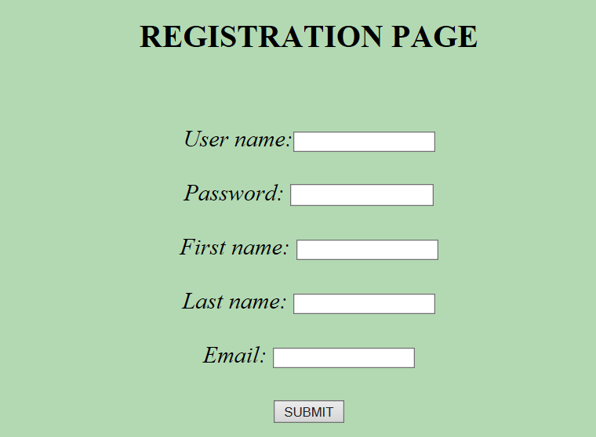

**Registration done:**

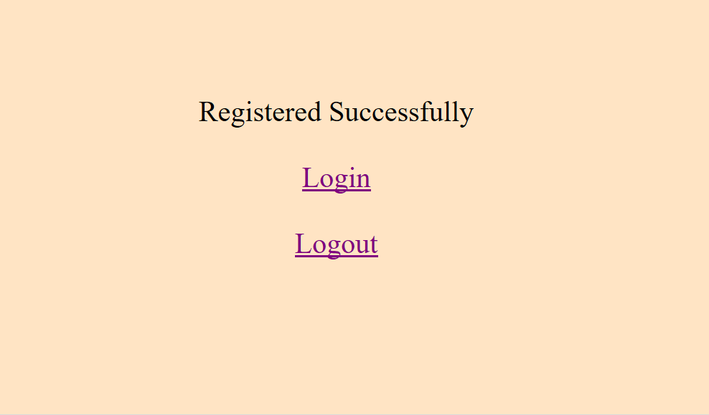

**Login Page:**

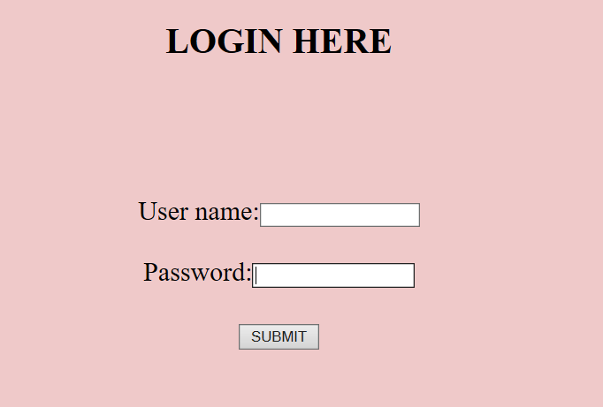

**Database Value:**

